Laggy shell casing noises?
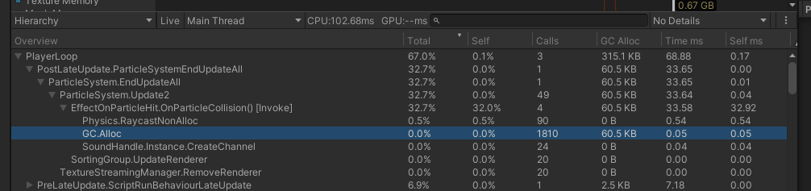
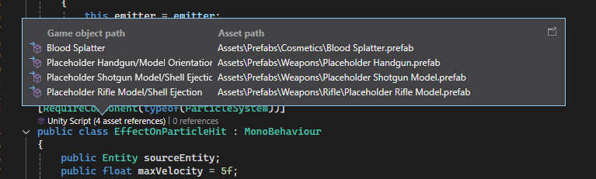

The blood splatter effect isn’t being used, and the lag occurs when shooting a gun, so something in my effect code is causing a ton of garbage collection.

Could it be ParticleSystem.GetCollisionEvents()? The documentation said the version I’m using is the one that doesn’t make garbage.
Since the sound played is a DiegeticSound, is the lag from the AI checks? I should add code to disable that, and see what happens.

There seems to still be a lot of dodgy optimisation when it comes to sound checks, and certain events causing lots of diegetic sound checks at the same time.

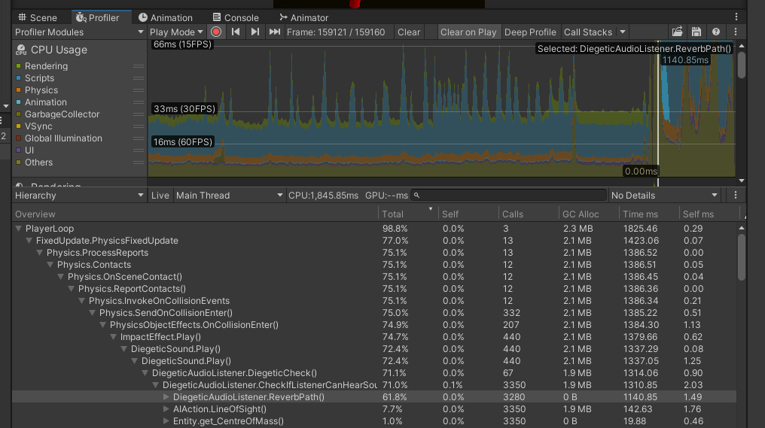

Another check to confirm:
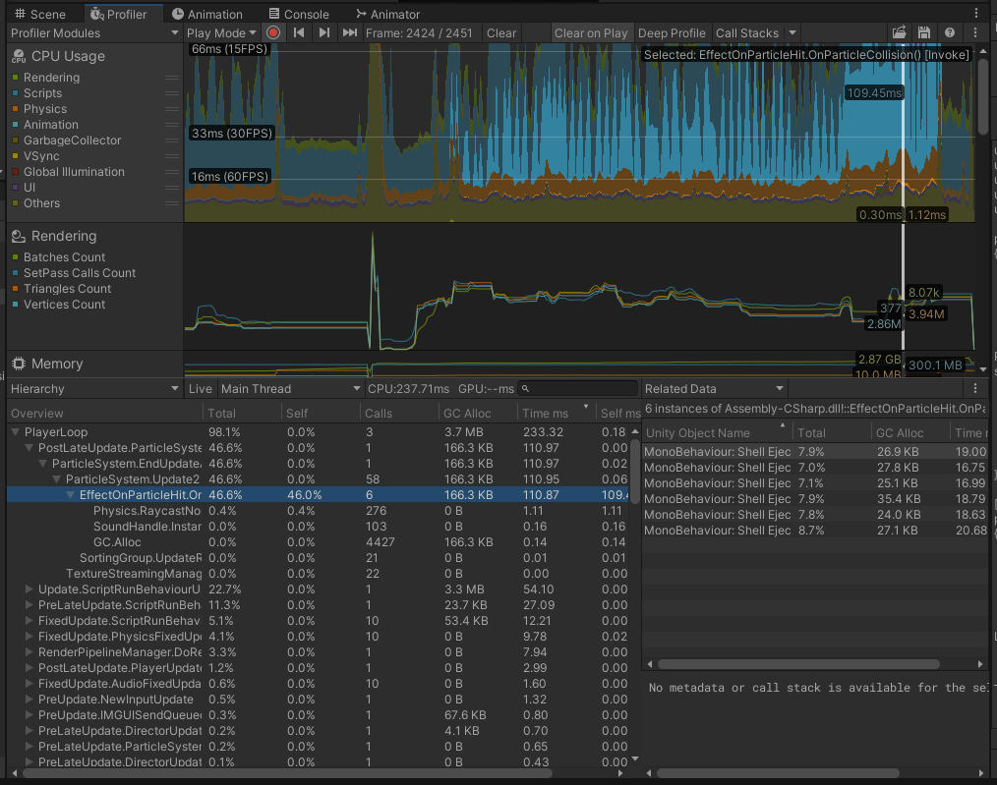
Unusual.
Did it have something to do with the two different path calculation methods for the sound check propagation?
No, seems to be the same either way (plus the old version causes a heap of debug message spam)

16/09/2026
I did some deep profiling and found the stack trace for the shell casing noises.
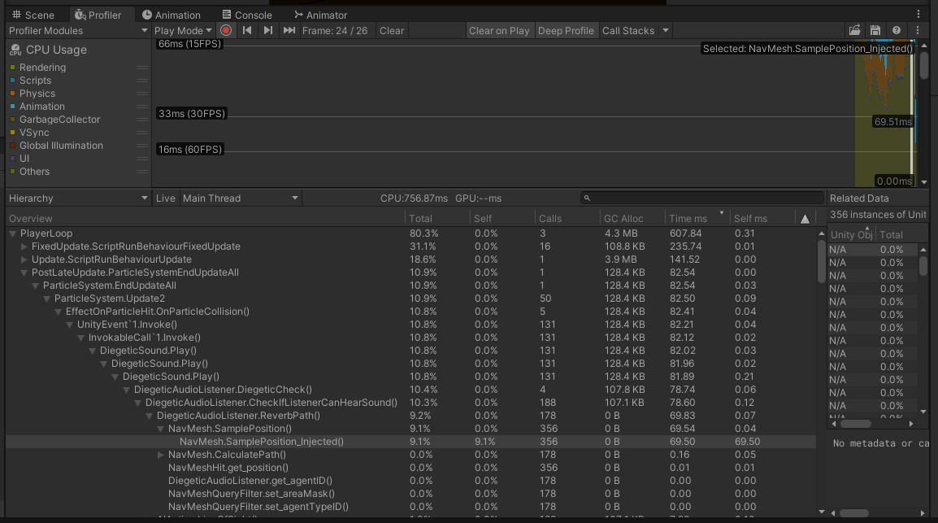
It seems most of the computational cost (for the particle collision sound effects) is from NavMesh.SamplePosition(), or at least some kind of sub-function. I’ll need to look into this.

